

**Computer Vision Project Group - 7**

**Week-6: Progress Report**

**Project Title:**

**American Sign Language Alphabet Detection**

**Submitted to faculty: Prof. Mehul Raval**

**Group Members:**

| **JILL SHAH** | **AU2040234** |
| --- | --- |
| **KHUSHEE VAKIL** | **AU2040242** |
| **DHRUVI SHAH** | **AU2040263** |

In this week we have worked further on our coding part. We have classified our data in training and validation sets and labeled the different classes. There are 26 classes from a to z and one more class of unknown.

Till now we have implemented the code for training our dataset which is as follows:

Here we are trying to differentiate our dataset between training dataset and validation dataset.

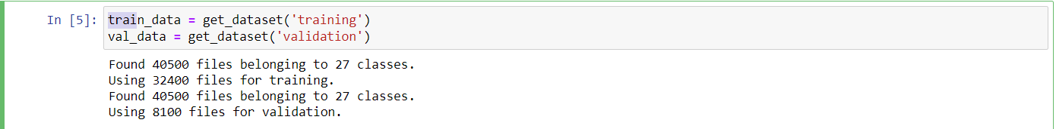

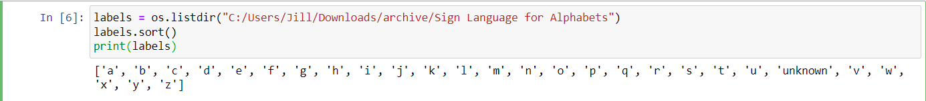

Here is the code in which we are extracting the labels of the output classes. So as we can see there are a total 27 classes as shown in the above picture.



